5. Facelets Example
- In a typical JSF application, each page of the application connects to a managed bean that serves the backing bean.
- The backing bean defines the method and properties that are associated with the components.
- For developing JSF application the following tasks are usually required.
- Developing the managed beans
- Creating the pages using the component tags
- Defining page navigation
- Mapping the FacesServlet instance
- Adding managed bean declarations
- Lets have FirstJSF directory as shown below

web.xml
<?xml version="1.0" encoding="UTF-8"?>
<web-app version="3.1" xmlns="http://xmlns.jcp.org/xml/ns/javaee" xmlns:xsi="http://www.w3.org/2001/XMLSchema-instance" xsi:schemaLocation="http://xmlns.jcp.org/xml/ns/javaee http://xmlns.jcp.org/xml/ns/javaee/web-app_3_1.xsd">
<context-param>
<param-name>javax.faces.PROJECT_STAGE</param-name>
<param-value>Development</param-value>
</context-param>
<servlet>
<servlet-name>Faces Servlet</servlet-name>
<servlet-class>javax.faces.webapp.FacesServlet</servlet-class>
<load-on-startup>1</load-on-startup>
</servlet>
<servlet-mapping>
<servlet-name>Faces Servlet</servlet-name>
<url-pattern>/faces/*</url-pattern>
</servlet-mapping>
<session-config>
<session-timeout>
30
</session-timeout>
</session-config>
<welcome-file-list>
<welcome-file>faces/login.xhtml</welcome-file>
</welcome-file-list>
</web-app>

LoginBean.java
package FirstJSF;

import javax.faces.bean.ManagedBean;
import javax.faces.bean.RequestScoped;
import javax.faces.bean.SessionScoped;
import javax.inject.Named;

@ManagedBean(name = "LoginBean")
@SessionScoped
public class LoginBean {

String fname, lname;
int id;

public void setFname(String fname) {
this.fname = fname;
}

public void setLname(String lname) {
this.lname = lname;
}

public void setId(int id) {
this.id = id;
}

public String getFname() {
return fname;
}

public String getLname() {
return lname;
}

public int getId() {
return id;
}
}

login.xhtml
<?xml version='1.0' encoding='UTF-8' ?>
<!DOCTYPE html PUBLIC "-//W3C//DTD XHTML 1.0 Transitional//EN" "http://www.w3.org/TR/xhtml1/DTD/xhtml1-transitional.dtd">
<html xmlns="http://www.w3.org/1999/xhtml"
xmlns:h="http://xmlns.jcp.org/jsf/html">
<h:head>
<title>Login Page</title>
</h:head>
<h:body>
<h:form>
First Name : <h:inputText id="fname" value="#{LoginBean.fname}"/><br></br>
Last Name : <h:inputText id="lname" value="#{LoginBean.lname}"/><br></br>
<h:commandButton id="submit" value="submit" action="response"/>
</h:form>
</h:body>
</html>

response.xhtml
<?xml version='1.0' encoding='UTF-8' ?>
<!DOCTYPE html PUBLIC "-//W3C//DTD XHTML 1.0 Transitional//EN" "http://www.w3.org/TR/xhtml1/DTD/xhtml1-transitional.dtd">
<html xmlns="http://www.w3.org/1999/xhtml"
xmlns:h="http://xmlns.jcp.org/jsf/html">
<h:head>
<title>Facelet Title</title>
</h:head>
<h:body>
Hello #{LoginBean.fname} #{LoginBean.lname} !!! <br></br>
How are you doing ?
</h:body>
</html>

login.xhtml

response.xhtml

- An <h:inputText> tag accepts user input and sets the value of the managed bean property userNumber.
- The input value is validated by validator tag <f:validateLongRange>.
- Configuring a JavaServer Faces application involves mapping the Faces Servlet in theweb deployment descriptor file, such as a web.xml file, and possibly adding managed bean declarations, navigation rules, and resource bundle declarations to the application configuration resource file, faces-config.xml.
- In web.xml we define context parameter PROJECT_STAGE. The stage of application can affect the behavior of application. If PROJECT_STAGE is defined as 'Development' then debugging information is automatically generated. The default stage is 'Production'.

- Example : How dynamic navigation takes place through 'action' attribute.
Lets create ActionMethodCheck directory as shown below

web.xml
<?xml version="1.0" encoding="UTF-8"?>
<web-app version="3.1" xmlns="http://xmlns.jcp.org/xml/ns/javaee" xmlns:xsi="http://www.w3.org/2001/XMLSchema-instance" xsi:schemaLocation="http://xmlns.jcp.org/xml/ns/javaee http://xmlns.jcp.org/xml/ns/javaee/web-app_3_1.xsd">
<context-param>
<param-name>javax.faces.PROJECT_STAGE</param-name>
<param-value>Development</param-value>
</context-param>
<servlet>
<servlet-name>Faces Servlet</servlet-name>
<servlet-class>javax.faces.webapp.FacesServlet</servlet-class>
<load-on-startup>1</load-on-startup>
</servlet>
<servlet-mapping>
<servlet-name>Faces Servlet</servlet-name>
<url-pattern>/faces/*</url-pattern>
</servlet-mapping>
<session-config>
<session-timeout>
30
</session-timeout>
</session-config>
<welcome-file-list>
<welcome-file>faces/login.xhtml</welcome-file>
</welcome-file-list>
</web-app>

faces-config.xml
<?xml version="1.0"?>
<faces-config xmlns="http://java.sun.com/xml/ns/javaee"
xmlns:xsi="http://www.w3.org/2001/XMLSchema-instance"
xsi:schemaLocation="http://java.sun.com/xml/ns/javaee
http://java.sun.com/xml/ns/javaee/web-facesconfig_2_0.xsd"
version="2.0">
<navigation-rule>
<navigation-case>
<from-outcome>response1</from-outcome>
<to-view-id>/home.xhtml</to-view-id>
</navigation-case>
</navigation-rule>
<navigation-rule>
<navigation-case>
<from-outcome>response2</from-outcome>
<to-view-id>/nonmember.xhtml</to-view-id>
</navigation-case>
</navigation-rule>
</faces-config>

EmployeeBean.java
package act;

import javax.faces.bean.ManagedBean;
import javax.faces.bean.SessionScoped;

@ManagedBean(name="empbean")
@SessionScoped

public class EmployeeBean {

public EmployeeBean() {
}

String name;
int empid;
int [] empids = {111,222,333,444,555};

public String getName() {
return name;
}

public void setName(String name) {
this.name = name;
}

public int getEmpid() {
return empid;
}

public void setEmpid(int empid) {
this.empid = empid;
}

public String valEmpId()
{
for(int i=0;i<empids.length;i++)
{
while(empid==empids[i])
{

return "home";
}
}
return "nonmember";
}
}

login.xhtml
<?xml version='1.0' encoding='UTF-8' ?>
<!DOCTYPE html PUBLIC "-//W3C//DTD XHTML 1.0 Transitional//EN" "http://www.w3.org/TR/xhtml1/DTD/xhtml1-transitional.dtd">
<html xmlns="http://www.w3.org/1999/xhtml"
xmlns:h="http://xmlns.jcp.org/jsf/html">
<h:head>
<title>Login Page</title>
</h:head>
<h:body>
<h:form>
<h:outputLabel value="Name : "/>
<h:inputText id="name" value="${empbean.name}"/><br/>

<h:outputLabel value="EmpID : "/>
<h:inputText id="empid" value="${empbean.empid}"/><br/>

<h:commandButton id="submit" value="submit" action="#{empbean.valEmpId}"/>
</h:form>
</h:body>
</html>

home.xhtml
<?xml version='1.0' encoding='UTF-8' ?>
<!DOCTYPE html PUBLIC "-//W3C//DTD XHTML 1.0 Transitional//EN" "http://www.w3.org/TR/xhtml1/DTD/xhtml1-transitional.dtd">
<html xmlns="http://www.w3.org/1999/xhtml"
xmlns:h="http://xmlns.jcp.org/jsf/html">
<h:head>
<title>Home Page</title>
</h:head>
<h:body>
Welcome ${empbean.name}
</h:body>
</html>

nonmember.xhtml
<?xml version='1.0' encoding='UTF-8' ?>
<!DOCTYPE html PUBLIC "-//W3C//DTD XHTML 1.0 Transitional//EN" "http://www.w3.org/TR/xhtml1/DTD/xhtml1-transitional.dtd">
<html xmlns="http://www.w3.org/1999/xhtml"
xmlns:h="http://xmlns.jcp.org/jsf/html">
<h:head>
<title>Non Member Page</title>
</h:head>
<h:body>
Sorry #{empbean.name} you are not allowed !!!
</h:body>
</html>

Output
1) login.xhtml
home.xhtml

2)
login.xhtml

nonmember.xhtml

6. Facelets Templating Tags
- Templating feature allows one to create a page that will act as the base, or template, for other pages in an application. It helps in maintaining standard look and feel in an application with large number of pages.
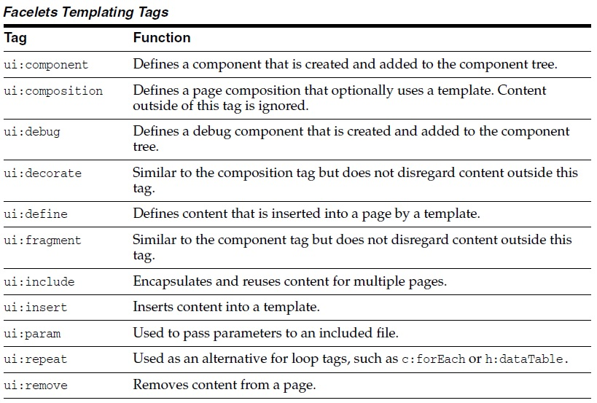
<ui:insert>
<ui:composition>
<ui:define>

- Lets have TemplatePjt directory as shown below
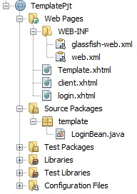

web.xml
<?xml version="1.0" encoding="UTF-8"?>
<web-app xmlns:xsi="http://www.w3.org/2001/XMLSchema-instance" xmlns="http://java.sun.com/xml/ns/javaee" xsi:schemaLocation="http://java.sun.com/xml/ns/javaee http://java.sun.com/xml/ns/javaee/web-app_3_0.xsd" version="3.0">
<display-name>TemplateProject</display-name>
<servlet>
<servlet-name>Faces Servlet</servlet-name>
<servlet-class>javax.faces.webapp.FacesServlet</servlet-class>
<load-on-startup>1</load-on-startup>
</servlet>
<servlet-mapping>
<servlet-name>Faces Servlet</servlet-name>
<url-pattern>/faces/*</url-pattern>
</servlet-mapping>
<context-param>
<description>State saving method: 'client' or 'server' (=default). See JSF Specification 2.5.2</description>
<param-name>javax.faces.STATE_SAVING_METHOD</param-name>
<param-value>client</param-value>
</context-param>
<context-param>
<param-name>javax.servlet.jsp.jstl.fmt.localizationContext</param-name>
<param-value>resources.application</param-value>
</context-param>
<listener>
<listener-class>com.sun.faces.config.ConfigureListener</listener-class>
</listener>
<welcome-file-list>
<welcome-file>Login.xhtml</welcome-file>
</welcome-file-list>
</web-app>

login.xhtml
<?xml version="1.0" encoding="ISO-8859-1" ?>
<!DOCTYPE html PUBLIC "-//W3C//DTD XHTML 1.0 Strict//EN" "http://www.w3.org/TR/xhtml1/DTD/xhtml1-strict.dtd">
<html xmlns="http://www.w3.org/1999/xhtml"
xmlns:c="http://java.sun.com/jsf/core"
xmlns:ui = "http://java.sun.com/jsf/facelets"
xmlns:h = "http://java.sun.com/jsf/html">

<h:body>
<h:form>
Enter name : <h:inputText id="name" value="#{LoginBean.name}"/>
<h:commandButton id="submit" value="submit" action="client"/>
</h:form>
</h:body>
</html>

template.xhtml
<?xml version="1.0" encoding="ISO-8859-1" ?>
<!DOCTYPE html PUBLIC "-//W3C//DTD XHTML 1.0 Strict//EN" "http://www.w3.org/TR/xhtml1/DTD/xhtml1-strict.dtd">
<html xmlns="http://www.w3.org/1999/xhtml"
xmlns:c="http://java.sun.com/jsf/core"
xmlns:ui = "http://java.sun.com/jsf/facelets"
xmlns:h = "http://java.sun.com/jsf/html">

<h:body>
<ui:insert name="message"/>
</h:body>
</html>

client.xhtml

<?xml version="1.0" encoding="ISO-8859-1" ?>
<!DOCTYPE html PUBLIC "-//W3C//DTD XHTML 1.0 Strict//EN" "http://www.w3.org/TR/xhtml1/DTD/xhtml1-strict.dtd">
<html xmlns="http://www.w3.org/1999/xhtml"
xmlns:c="http://java.sun.com/jsf/core"
xmlns:ui = "http://java.sun.com/jsf/facelets"
xmlns:h = "http://java.sun.com/jsf/html">

<h:body>
<h:form>
<ui:composition template = "/template.xhtml">

<ui:define name = "message">
Hello #{LoginBean.name}
</ui:define>

</ui:composition>
</h:form>
</h:body>
</html>

Output

login.xhtml

client.xhtml

7. Facelets Composite Component

- Composite components is a special type of template that acts as a component.
- The web page that uses composite component is generally called as using page.

Most commonly used composite components are listed below

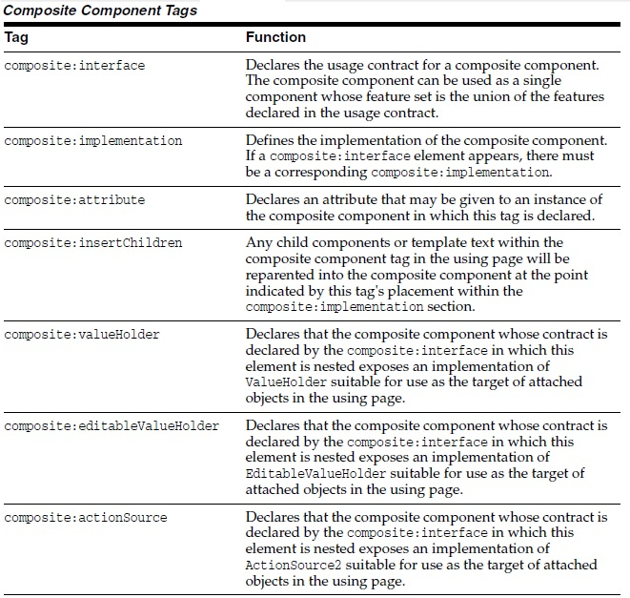

- Example
Here <composite:interface>, <composite:attribute> and <composite:implementation> is used.
Lets create a CompositePjt directory as shown below

web.xml
<?xml version="1.0" encoding="UTF-8"?>
<web-app version="3.1" xmlns="http://xmlns.jcp.org/xml/ns/javaee" xmlns:xsi="http://www.w3.org/2001/XMLSchema-instance" xsi:schemaLocation="http://xmlns.jcp.org/xml/ns/javaee http://xmlns.jcp.org/xml/ns/javaee/web-app_3_1.xsd">
<context-param>
<param-name>javax.faces.PROJECT_STAGE</param-name>
<param-value>Development</param-value>
</context-param>
<servlet>
<servlet-name>Faces Servlet</servlet-name>
<servlet-class>javax.faces.webapp.FacesServlet</servlet-class>
<load-on-startup>1</load-on-startup>
</servlet>
<servlet-mapping>
<servlet-name>Faces Servlet</servlet-name>
<url-pattern>/faces/*</url-pattern>
</servlet-mapping>
<session-config>
<session-timeout>
30
</session-timeout>
</session-config>
<welcome-file-list>
<welcome-file>faces/usingPage.xhtml</welcome-file>
</welcome-file-list>
</web-app>

employee.xhtml

<?xml version='1.0' encoding='UTF-8' ?>
<!DOCTYPE html PUBLIC "-//W3C//DTD XHTML 1.0 Transitional//EN" "http://www.w3.org/TR/xhtml1/DTD/xhtml1-transitional.dtd">
<html xmlns="http://www.w3.org/1999/xhtml"
xmlns:h="http://xmlns.jcp.org/jsf/html"
xmlns:composite="http://xmlns.jcp.org/jsf/composite">
<h:head>
<title>This content will not be displayed</title>
</h:head>
<h:body>
<composite:interface>
<composite:attribute name="fname" required="false"/>
<composite:attribute name="lname" required="false"/>
<composite:attribute name="emid" required="false"/>
</composite:interface>

<composite:implementation>

<br> <h:outputLabel value ="first name: "/>
<h:inputText id="fname" value="#{cc.attrs.fname}"/></br>

<br> <h:outputLabel value="last name: "/>
<h:inputText id="lname" value="#{cc.attrs.lname}"/></br>

<br> <h:outputLabel value="Email id: "/>
<h:inputText value="#{cc.attrs.emid}"/></br>

</composite:implementation>
</h:body>
</html>

Note : Above the local composite component library is defined in xmlns namespace with declaration xmlns:composite="http://xmlns.jcp.org/jsf/composite"

LoginBean.java

package comp;

import javax.faces.bean.ManagedBean;
import javax.faces.bean.SessionScoped;

@ManagedBean(name = "loginbean")
@SessionScoped
public class LoginBean {

String fname, lname, emid;

public String getFname() {
return fname;
}

public void setFname(String fname) {
this.fname = fname;
}

public String getLname() {
return lname;
}

public void setLname(String lname) {
this.lname = lname;
}

public String getEmid() {
return emid;
}

public void setEmid(String emid) {
this.emid = emid;
}
}

usingPage.xhtml

<?xml version='1.0' encoding='UTF-8' ?>
<!DOCTYPE html PUBLIC "-//W3C//DTD XHTML 1.0 Transitional//EN" "http://www.w3.org/TR/xhtml1/DTD/xhtml1-transitional.dtd">
<html xmlns="http://www.w3.org/1999/xhtml"
xmlns:h="http://xmlns.jcp.org/jsf/html"
xmlns:em="http://xmlns.jcp.org/jsf/composite/comp">
<h:head>
<title>Using Page</title>
</h:head>
<h:body>
<h:form>
<em:employee
fname="#{loginbean.fname}"
lname="#{loginbean.lname}"
emid="#{loginbean.emid}"
/>

<h:commandButton id="submit" value="submit" action="finalPage"/>

</h:form>
</h:body>
</html>

Note : Above we can see the components are accessed through em:employee tag.

finalPage.xhtml

<?xml version='1.0' encoding='UTF-8' ?>
<!DOCTYPE html PUBLIC "-//W3C//DTD XHTML 1.0 Transitional//EN" "http://www.w3.org/TR/xhtml1/DTD/xhtml1-transitional.dtd">
<html xmlns="http://www.w3.org/1999/xhtml"
xmlns:h="http://xmlns.jcp.org/jsf/html">
<h:head>
<title>Final Page</title>
</h:head>
<h:body>
<br>Hello #{loginbean.fname} #{loginbean.lname}</br>
your email id is : #{loginbean.emid}
</h:body>
</html>

Output

usingPage.xhtml

finalPage.xhtml

7. Web Resources

- Web resources are software artifacts which application requires for proper working. Resources must be collected at a standard location which will be one of the following.
a. A resource packaged in the web application root must be in a subdirectory of a resources directory at the web application root: resources/resource-identifier.
b. A resource packaged in the web application's classpath must be in a subdirectory of the META-INF/resources directory within a web application: META-INF/resources/resource-identifier. You can use this file structure to package resources in a JAR file bundled in the web application.
- (*) The JSF runtime will look for the resources in the preceding listed locations, in that order.
- Resource identifiers are unique strings that conform to the following format.
[locale-prefix/][library-name/][library-version/]resource-name[/resource-version]

- Example :
<h:outputStylesheet library="css" name="default.css"/>
This tag specifies that the default.css style sheet is in the directory web/resources/css.
<h:graphicImage value="#{resource['images:wave.med.gif']}"/>
This tag specifies that the image named wave.med.gif is in the directory web/resources/images.
- Resources can be considered as a library location. Any component or template stored in resource directory becomes accessible to other application components.

8. Resource Library Contracts
- One could have a different look and feel for one or more part of the application. To do this one has to create contracts section of web application.
- Inside contracts section one can specify number of named areas each of which is called contract. Within each contract one can specify resources such as template files, style sheets, JavaScript files and Images.
- For example, two contracts c1 and c2 are as shown below

- One can package resource library contract in a JAR file to reuse in different applications. If one do so then contract must be located under META-INF/contracts. JAR file then can be placed under WEB-INF/lib directory of an application.
- (*) One can also specify contract usage within the applcation's faces-config.xml file under resource-libarary-contracts element as shown below. This element will be used only if application is using more than one contract.
<resource-library-contracts>
<contract-mapping>
<url-pattern>/reply/*</url-pattern>
<contracts>reply</contracts>
</contract-mapping>
<contract-mapping>
<url-pattern>*</url-pattern>
<contracts>hello</contracts>
</contract-mapping>
</resource-library-contracts>

- Example
Lets create a directory ContractsPjt as shown below

web.xml
<?xml version="1.0" encoding="UTF-8"?>
<web-app version="3.1" xmlns="http://xmlns.jcp.org/xml/ns/javaee" xmlns:xsi="http://www.w3.org/2001/XMLSchema-instance" xsi:schemaLocation="http://xmlns.jcp.org/xml/ns/javaee http://xmlns.jcp.org/xml/ns/javaee/web-app_3_1.xsd">
<context-param>
<param-name>javax.faces.PROJECT_STAGE</param-name>
<param-value>Development</param-value>
</context-param>
<servlet>
<servlet-name>Faces Servlet</servlet-name>
<servlet-class>javax.faces.webapp.FacesServlet</servlet-class>
<load-on-startup>1</load-on-startup>
</servlet>
<servlet-mapping>
<servlet-name>Faces Servlet</servlet-name>
<url-pattern>/faces/*</url-pattern>
</servlet-mapping>
<session-config>
<session-timeout>
30
</session-timeout>
</session-config>
<welcome-file-list>
<welcome-file>faces/login.xhtml</welcome-file>
</welcome-file-list>
</web-app>

faces-config.xml
<?xml version='1.0' encoding='UTF-8'?>
<faces-config version="2.2"
xmlns="http://xmlns.jcp.org/xml/ns/javaee"
xmlns:xsi="http://www.w3.org/2001/XMLSchema-instance"
xsi:schemaLocation="http://xmlns.jcp.org/xml/ns/javaee http://xmlns.jcp.org/xml/ns/javaee/web-facesconfig_2_2.xsd">
<application>
<resource-library-contracts>
<contract-mapping>
<url-pattern>*</url-pattern>
<contracts>contract1</contracts>
</contract-mapping>
<contract-mapping>
<url-pattern>/response/*</url-pattern>
<contracts>contract2</contracts>
</contract-mapping>
</resource-library-contracts>
</application>
</faces-config>

template1.xhtml
<?xml version='1.0' encoding='UTF-8' ?>
<!DOCTYPE html PUBLIC "-//W3C//DTD XHTML 1.0 Transitional//EN" "http://www.w3.org/TR/xhtml1/DTD/xhtml1-transitional.dtd">
<html xmlns="http://www.w3.org/1999/xhtml"
xmlns:h="http://xmlns.jcp.org/jsf/html"
xmlns:ui="http://xmlns.jcp.org/jsf/facelets">
<h:head>
<title>Template 1</title>
</h:head>
<h:body>
<h1>Welcome to Login Page</h1>
<h:graphicImage url="#{resource['welcome.jpeg']}"/><br/>
<ui:insert name="content"/>
</h:body>
</html>

template2.xhtml
<?xml version='1.0' encoding='UTF-8' ?>
<!DOCTYPE html PUBLIC "-//W3C//DTD XHTML 1.0 Transitional//EN" "http://www.w3.org/TR/xhtml1/DTD/xhtml1-transitional.dtd">
<html xmlns="http://www.w3.org/1999/xhtml"
xmlns:h="http://xmlns.jcp.org/jsf/html"
xmlns:ui="http://xmlns.jcp.org/jsf/facelets">
<h:head>
<title>Template 2</title>
</h:head>
<h:body>
<h1>Home Page</h1>
<h:graphicImage url="#{resource['apple.jpeg']}"></h:graphicImage><br/>
<ui:insert name="message"/>
</h:body>
</html>
login.xhtml
<?xml version='1.0' encoding='UTF-8' ?>
<!DOCTYPE html PUBLIC "-//W3C//DTD XHTML 1.0 Transitional//EN" "http://www.w3.org/TR/xhtml1/DTD/xhtml1-transitional.dtd">
<html xmlns="http://www.w3.org/1999/xhtml"
xmlns:h="http://xmlns.jcp.org/jsf/html"
xmlns:ui="http://xmlns.jcp.org/jsf/facelets" >

<h:head>
<title>Login Page</title>
</h:head>

<ui:composition template="/template1.xhtml">

<ui:define name="content">
<h:form>
First Name : <h:inputText id="fname" value="#{empbean.fname}"/><br/>
Last Name : <h:inputText id="lname" value="#{empbean.lname}"/><br/>
<h:commandButton id="submit" value="Submit" action="response/home">
</h:commandButton>
</h:form>
</ui:define>

</ui:composition>

</html>

home.xhtml
<?xml version='1.0' encoding='UTF-8' ?>
<!DOCTYPE html PUBLIC "-//W3C//DTD XHTML 1.0 Transitional//EN" "http://www.w3.org/TR/xhtml1/DTD/xhtml1-transitional.dtd">
<html xmlns="http://www.w3.org/1999/xhtml"
xmlns:h="http://xmlns.jcp.org/jsf/html"
xmlns:ui="http://xmlns.jcp.org/jsf/facelets">

<h:head>
<title>Home Page</title>
</h:head>
<ui:composition template="/template2.xhtml">

<ui:define name="message">
<h:body>
Hello #{empbean.fname} #{empbean.lname}
</h:body>
</ui:define>
</ui:composition>

</html>

LoginBean.java
package cont;

import javax.faces.bean.ManagedBean;
import javax.faces.bean.SessionScoped;
/**
* @author Jayant
*/
@ManagedBean(name="empbean")
@SessionScoped
public class EmployeeBean {
public EmployeeBean() {
}

String fname,lname;

public String getFname() {
return fname;
}

public void setFname(String fname) {
this.fname = fname;
}

public String getLname() {
return lname;
}

public void setLname(String lname) {
this.lname = lname;
}
}

Output
login.xhtml
home.xhtml

